# Information Visualization

# CHECKPOINT IV: First Prototype

G01-A

**1. Layout**

Like we said, in the previous classes, we created 3 tabs in html. One with the standings of the countries, one with the coefficient medal/population, and the last one with a score compare of countries that the user previously declares. Besides that, we also made attributes like a range of years, the sport we want to filter and the medal that the user will want to know information of. In the Standings tab and in the Coefficient tab we have a “Search Country” box that has the function to locate a country in the rank and in the map, by changing is colour.

**2. Implemented Idioms**

For the Standings tab and the Coefficient tab, we made a Bar Chart, where each country was presented has a rank. It had the countries in the left, and in the center, the bars that we’re complemented with a length that specifies the amount of medals or coefficient medals/population a country had in a particular year, or range of years. We also put it after the bars a text label representing the amount of medals/coefficient the corresponding country had. In the end, we had something like this:

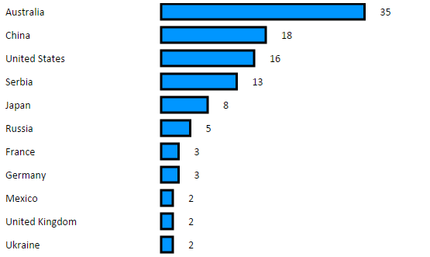

Based on his simplicity, when the user puts the mouse on the top of a bar of a specific country, it would present to him the IOC code of the country. Also, in the search box that we referenced in the first paragraph, when a user looks for a country, the colour of that country bar chart changes to another colour; the intention is to highlight the difference and spot the differences of that country and the other countries

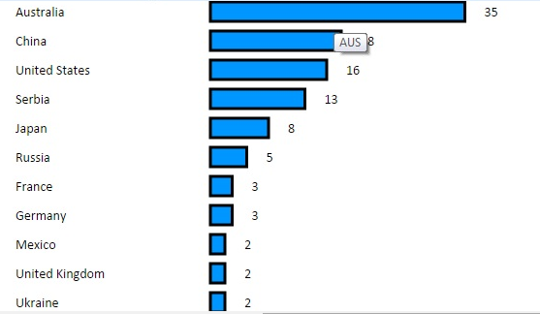 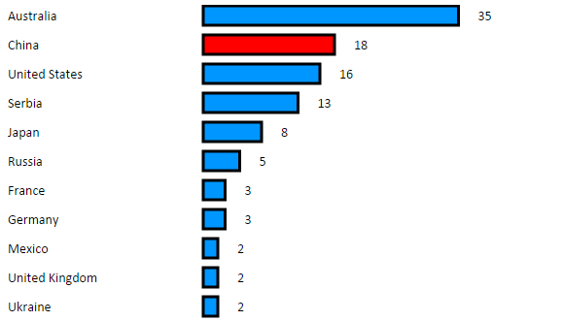

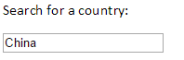

In the Compare Tab, we write the countries in the text boxes presented, and then the colour of the selected countries bars will change. It will only appear the bars of the two countries we selected in the right side of the visualization.

In the Coefficient Tab, we had some interactivity with the second idiom. When we clicked on the bar of a country, the bar changed his colour, and then something will append also in the second idiom.

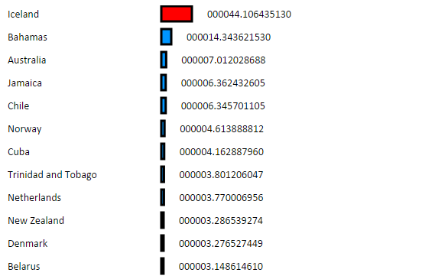

We have has the second idiom, a bubble chart in a world coordinated map. The idea was to make a chart in a map to reference the location of the country in the back, and bubbles that represent the amount of medals or coefficient medal/population in all countries. The bigger were the amount of medals or their coefficient, the bigger the bubbles would be; this way, was easier to know the countries that have more and less. We had to some bubbles (those who had more than 10 medals) a label that shows the amount of medals in a country. We done the label example for the Standings and the Compare Tab, but not in the Coefficient Tab because in some countries we had big differences, such as values like 44,5 and 0,2. So for that tab we only used the length and the bubbles to determine the amount.

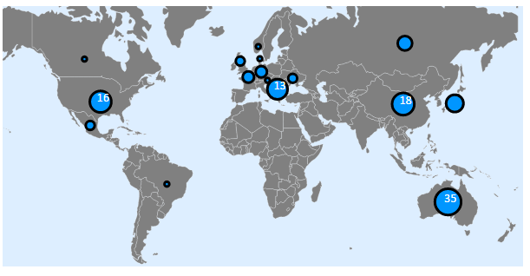

Like in the first idiom, if a user puts the mouse in a circle, it will appear a text with information about the country, the ISO code of the country and the number of medals/coefficient that country had. Also, if the user searches for a country, the bubble of the country will change the colour to highlight the country in the map.

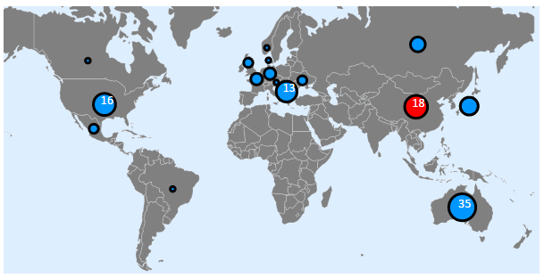



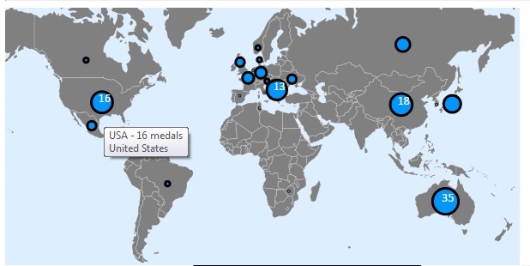

In the Compare Tab, we write the countries in the text boxes presented, and then the colour of the selected countries bubbles will change. This way, we can compare the locations of the countries we selected and have a previous idea of what to expect from the countries, by simply observe they’re bubble sizes.

Previously, we talked about an interactivity between the two idioms in the coefficient tab. When we clicked on a bar, the bar changes is colour. But it also changes the colour of the bubble’s country. This is used to notify the country we selected automatically by simply clicking on the bar of a country, or even in the bubble of a country.

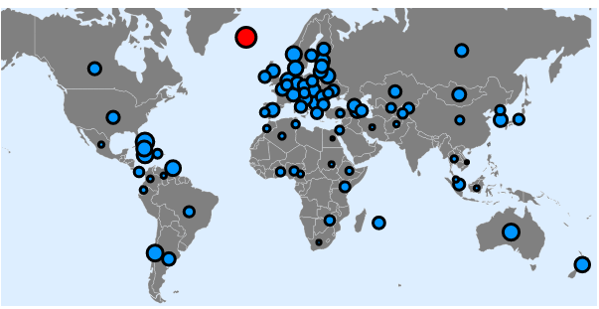

Last but not least, we made a function that allows the user to make zoom in the map image, by double clicking in a certain space of the map, or even drag the map, by clicking on the map and push to wherever we want to see. The bubbles in this case will not move, because we predefine in the begging they’re positions in the map. However, the size of the bubbles will have now a new dimension regathering the dimension of this “new” image.

